**Abstract**

Ratiometric, two-state fluorescent biosensors have become established and powerful tools to make absolute, quantitative measurements in living systems. A key question is how to compare the ranges of cellular properties biosensors are well-suited to measure. Here, we present an analysis of the suitability of biosensors with two states. For our workflow, we developed a user-friendly tool for examining sensor suitability, given microscopy error and physiochemical properties of the sensor (link). We compared the suitability of a family of glutathione redox-sensing biosensors and generalized our findings to all ratiometric biosensors with two states. Our analysis provides an integrated framework for comparing biosensors.

**Introduction**

The recent discovery and development of chemically-sensitive fluorescent protein biosensors has allowed for the absolute measurement of cellular properties of interest, such as redox, pH, and ATP, in live animals. Due to the nonlinear map between fluorescence intensity and the cellular property of interest, each biosensor is limited in the range of values it is well-suited to measure. Consequently, it is important to assess how physical and chemical properties affect the ability of biosensors to make accurate measurements. Previous studies have []. In this study, we used published data from existing biosensors and empirically-determined microscopy errors to quantify the accuracy of the biosensors in different environments.

We defined microscopy error as the variation in measured ratiometric intensity of an intensity-stable control sample, and we defined the biosensor accuracy as error in the measurement of the ultimate cellular property of interest, given the microscopy error. High accuracy allows for single measurements to [].

Publications presenting new biosensors often include biophysical spectral data, as well as empirically-determined chemical properties, such as midpoint potential. […]

Our analysis was subject to limitations […]. Nevertheless, our approach allows for the comparison across many published biosensors. This methodology highlights the need for new biosensors that target specific cellular environments while providing a standardized scale on which new sensors can be put in context of existing tools.

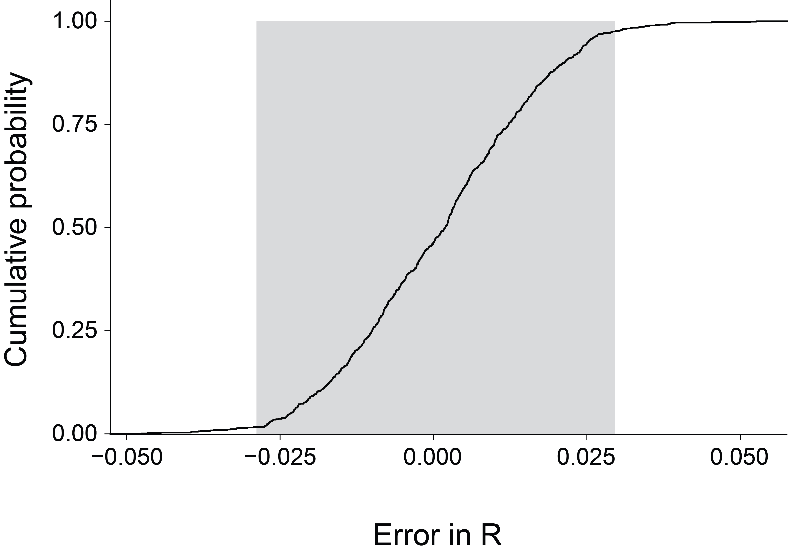

Questions: (1) What did we do? (2) What did we find? (3) What can we do now that we couldn’t do before?

* To determine the error in microscopy, we took ratio images of the pharynx of 64 *Caenorhabditis elegans* worms expressing roGFP1_R12 under normal conditions every 30-seconds for ten minutes. Using [], we fit the data and recorded the residuals as microscopy errors.
* We found that the middle 95% of our errors fell in the range of .
* The errors were roughly normal and zero-centered (Supplement).
* We confirmed our error with four independent experiments (Supplement).
* We can now use our empirically-determined microscopy imprecision to model how accurately we can measure redox potential.

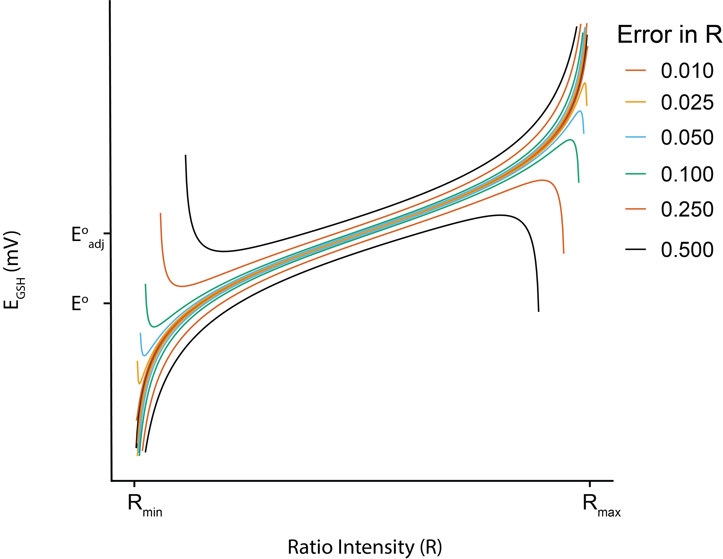

Questions: (1) What did we do? (2) What did we find? (3) What can we do now that we couldn’t do before?

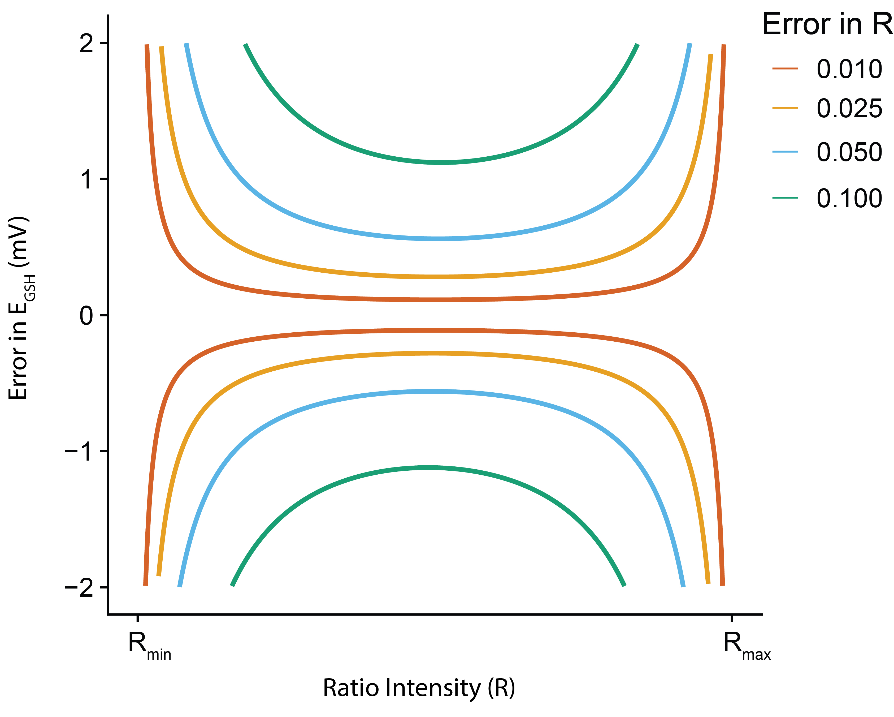

Questions: (1) What did we do? (2) What did we find? (3) What can we do now that we couldn’t do before?